

**Assignment Of**

**ITEC-516 Computer Graphics**

**Topic Computer Graphics and Applications**

**Submitted To:**

**Sir.Jawad Hussain Awan**

**Professor Dept:**

**Information Technology**

**Submitted By:**

**Mubashir Ali S/O**

**Mansoor Ali**

**(2k20/ITE/73) Group(A)**

**Computer Graphics**

**Introduction to Computer Graphics:**

Computer graphics illustrations is usually viewed as a software engineering branch that arrangements with the electronic picture combination hypothesis and innovation. As basic as a triangle frame, a computer graphics created picture might address a scene. The computer graphics has turned into an integral asset for delivering pictures rapidly and financially.

At the point when a computer graphics is utilized to make pictures, a similar cycle is followed as making pictures physically. The cycle's essential computational advances give a lift to a few significant computer graphics illustrations regions.

Additionally on computer graphics is, the term computer graphics designs covers nearly everything. Here in the computer graphics illustrations program's homeroom, we consider computer graphics designs drawing pictures on machines, frequently known as delivering. The pictures can be photographs, representations, movements, or pictures of things envisioned. Or on the other hand they might be pictures, we can't see straightforwardly, as inward body parts.

We have invested a lot of our effort to foster how computer graphics pictures can duplicate true scenes. We need objects on computer graphics is not exclusively to look all the more genuine, yet in addition their varieties to be more sensible and how various materials show up. We can allude to it as "real blend of the image."

The term computer graphics illustrations has been utilized to characterize "nearly everything on the computer graphics, including text or sound." Generally, the term computer graphics designs allude to the accompanying things:

* Computer graphics portrayal and control of picture information.
* Different innovations for making and controlling pictures.
* Computer graphics illustrations study is a sub-field of software engineering that reads up techniques for carefully consolidating and controlling visual substance.

The following area of computer graphics illustrations that arrangements with the position of a triangle is called change. Here we can utilize lattices to get the planning of a triangle in picture space. We can likewise set up the change lattice to control the area and direction of the showed picture. We can likewise resize the triangle.

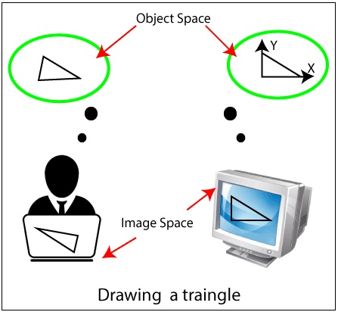

****Definition of Computer Graphics:****

Computer designs can be a progression of pictures which is most frequently called a video or single picture. computer graphics illustrations is the innovation that worries with plans and pictures on computer graphics. That is the reason, computer graphics illustrations are visual portrayals of information displayed on a screen made on a computer graphics.

"Computer designs plans is the use of a PC designs to describe, store, control, look at, and address the pictorial outcome." An image in PC illustrations delineations is contained different pixels.

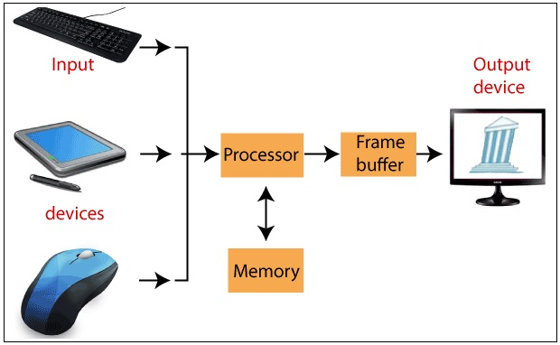

****Applications of Computer Graphics****

A few utilization's of computer graphics designs are referenced underneath.

**Graphical User Interface (GUI):**

It is an approach to cooperating with a computer graphics utilizing the symbol, menu, and other visual, illustrations by which client effectively communicates.

**Art:**

Computer Graphics gives a better approach for making plans. Numerous craftsmen and creators use artist, coral draw, Photo-shop, adobe muse, and different sorts of utilization's for making new plans.

**Entertainment:**

Computer illustrations permit the client to make vivified motion pictures and games. computer graphics designs are utilized to cause situations. computer graphics illustrations are additionally utilized for enhancements and movements.

**Presentations:**

Computer illustrations are utilized for making outlines, bar charts, and different pictures for the show reason, with the graphical show the client, can undoubtedly grasp the focuses.

**Engineering Drawings:**

Computer Graphics has additionally given us the adaptability to make 3D models, house circuits and designing drawings, and so on which is useful as far as we're concerned.

**Education and Training:**

Computer designs are additionally used to give preparing to understudies test systems. The understudies can find out about the machines without actually attempting them.

**Medical Imaging:**

MRI's, CT filters, and other inside examines are conceivable as a result of computer graphics designs.

**Flight Simulator:**

Computer realistic is utilized to give preparing to pilots of airplane. The pilots give a lot of chance to a pilot test program on the ground rather than genuine planes.

**Printing Technology:**

Computer illustrations are utilized in material planning and flex printing.

**Typography:**

Use of character pictures to supplant the harsh type of the past in printing.

**Satellite Imaging:**

Computer illustrations are utilized to gauge the development of the cloud and to foresee the climate.

**Cartography:**

Computer designs are utilized in map drawing.

**Computer Aided Design/CAM:**

CAD/CAM is otherwise called Computer-supported plan and computer graphics helped producing. Computer aided design/CAM is utilized to plan and assemble models, completed items, and assembling processes.

**Benefits of Computer Graphics**

A few significant advantages of Computer illustrations are:

* Increment Productivity.
* Computer graphics designs give us instruments for making pictures of strong articles as well as of hypothetical, designed objects.
* Computer graphics designs likewise bring up the moving pictures.
* The computer graphics can store complex drawings and show complex pictures.
* Sound cards are utilized to make computer graphics produce sound outcomes prompted different purposes of illustrations.

**Issues of Computer Graphics**

Some issues with computer graphics illustrations are:

* Equipment attributes and cost.
* Specialized issues.
* Coupling issues (show the Simulation).

***THE END***